How I Feel by Ameliyah
I am happy because I have a cat.

My Outing by Jasey
I went to play at the park. It was hot but it was raining.
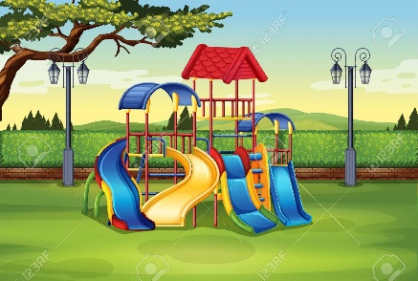

Home by Eliana
I am at home playing on my IPad and I am on the couch. Mum is watching me.

