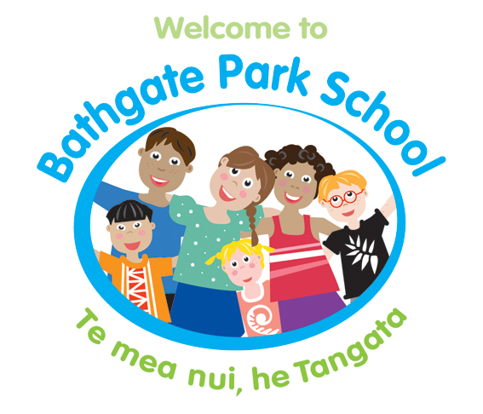

Bathgate Park School

213 Macandrew Road
South Dunedin 9012

Phone: 455 3421
E-mail katrina@bathgatepark.school.nz

Dear Parents / Caregivers

Donations
Food Donations

There are often times we are in a position to share food items with families that have been donated to the school, or are used at school, but due to expiry dates need to be used up, e.g. fruit; food items; Weetbix.

Sometimes businesses also donate food items to the school to distribute to families.

KidzCan Donations
Bathgate Park School is kindly supported by KidzCan and often they are able to help us support families with items such as windbreaker jackets, black school shoes; headlice treatments etc. The distribution of these items is on an individual needs basis and is overseen by the school.

We are aware that not all families will want to receive donations, so we are going to operate on an OPT OUT manner. If you DO NOT want donations sent home to you, please complete the following slip and return it to the school.

Kind Regards

Katrina Robertson
Principal

Donation Items Opt Out
We DO NOT want to receive food donation items. Tick if opting out
We DO NOT want to receive KidzCan donation items. Tick if opting out.

Child/ren’s Name(s)_________________________________
Class Name(s) __________________________
Parent Signature: ________________________

