Road Safety at BGP
At Bathgate Park, the safety of our students is paramount. For this reason, we would like to share some of ways you can help us keep our students safe around the roads.
Use our drop of zone to drop off and pick up children. This is NOT a parking space so please if you need to bring your child in, park somewhere else. | 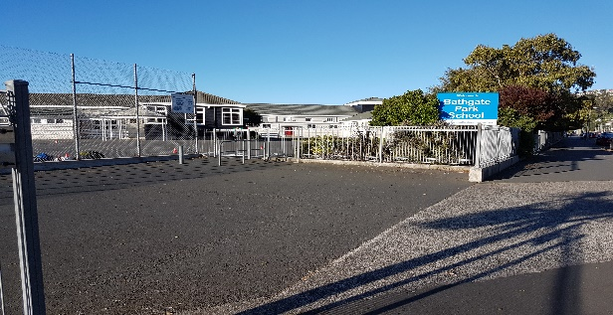
Use the available parking spaces if you are bringing your child into the school.  - Tonga Park Carpark (otherside of Dental Clinic)  - Macandrew Road Parking  - Bathgate Park Angle Parks (These are nearly always available) | 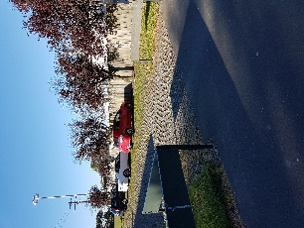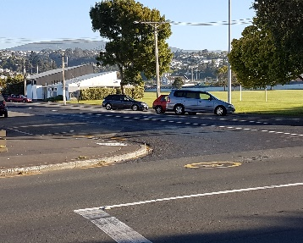
Please use the school crossing to cross Macandrew Road. Doing this sets a safe example to all our students. Cars move fast and pay attention to the crossing and the monitors. | 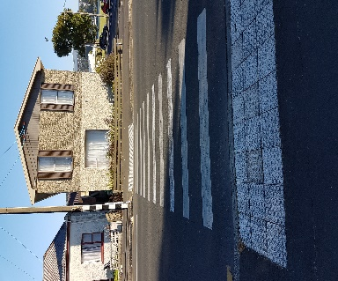
DO NOT park on the yellow lines. When you do it blocks the view the crossing monitors have of the road and also creates a blind spot for drivers coming to see children crossing. | 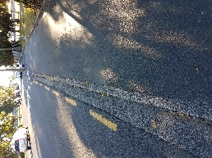
Please DO NOT come in the school front drive to drop off children. There are children in this area coming and going at all times of the day. This is a play area for children. | 